Restorative Exercise™
CLIENT INFORMATION QUESTIONNAIRE

All information received on this form will be treated as strictly confidential. Please fill out the forms completely and accurately. This information is essential to developing a program that addresses your needs, goals, and interests and is safe and effective.

Name:_ ______________________________ Date of Birth ____/____/____ Age: ______
M D Y
Address: __________________________________________________________________
Street City State Zip Code
Phone: (home)__________________ (wireless)________________ (fax)_______________

Email address: ____________________________________________________________

Occupation: _____________________________________

Emergency Contact: ________________________ Relationship: ________________

Phone Number: _________________________

Physician’s Name: ________________________ Physician’s Phone: _______________

Physician’s Address: ____________________________________________________
Street City State Zip Code

Please provide 24 hours notice if you need to cancel or reschedule
your appointment.

Austin Bowenwork™& Alignment Center
Holistic Body-Soul Healing
Jessica Riley, LMP, RBT, RYT
8727 Shoal Creek Blvd Austin, TX 78757
(512) 739-8299
Jessica@austinbowenwork.com
www.austinbowenwork.com

Health Status: Please mark YES or No to the following: YES NO

Has your doctor ever said that you have a heart condition and recommended only
medically supervised physical activity? ____ ____

Do you frequently have pains in your chest when you perform physical activity? ____ ____

Have you had chest pain when you were not doing physical activity? ____ ____

Do you lose your balance due to dizziness or do you ever lose consciousness? ____ ____

Do you have a bone, joint or any other health problem that causes you pain or
limitations that must be addressed when developing an exercise program (i.e.
diabetes, osteoporosis, high blood pressure, high cholesterol, arthritis, anorexia,
bulimia, anemia, epilepsy, respiratory ailments, back problems, etc.)? ____ ____

Are you pregnant now or have given birth within the last 6 months? ____ ____

Have you had a recent surgery? ____ ____

Please include information on ANY surgeries (cosmetic, outpatient, injury repair, reconstructive, laparoscopic, etc.), injuries, pregnancies, deliveries, cesareans, etc.

______________________________________________________________________________________

______________________________________________________________________________________

______________________________________________________________________________________

Do you take any medications, either prescription or non-prescription, on a regular basis? Circle…..Yes / No

What is the medication for? ________________________________________________________________

How does this medication affect your ability to exercise?

______________________________________________________________________________________

______________________________________________________________________________________

Please indicate your top 3 goals for your exercise session today:

1) __________________________ 2) ___________________________ 3) __________________________

PARTICIPANT RELEASE AND KNOWLEDGE OF AGREEMENT

- I, ____________________________________________, wish to participate in the exercise and training program offered by Jessica Riley, LMT, RBT, RES-CPT of Austin Bowenwork & Alignment Center. I understand there are inherent risks in participating in a program of exercise. Consequently, if I have any health related issues it is recommended that I be examined by a physician of my choice and have obtained his/her approval for my participation in a fitness program. I agree that Jessica Riley, LMT, RBT, RES-CPT and Austin Bowenwork & Alignment Center shall not be liable or responsible for any injuries to me resulting from my participation in the fitness program (whether at home, at the training studio, outdoors, or at a corporate, commercial, residential or other fitness facility) and I expressly release and discharge Jessica Riley, LMT, RBT, RES-CPT and Austin Bowenwork & Alignment Center from all claims, actions, judgments and the like which I or my heirs, executors, administrators or assigns may have or claim to have as a result of any injury or other damage which may occur in connection with my participation in the fitness program, excepting only an injury caused by the gross negligence or intentional act of such person or persons. This Release shall be binding upon my heirs, executors, administrators, and assigns.

I have read and understand this term: ________ (initial)

- I certify that the answers to the questions outlined on the questionnaire form are true and complete to the best of my knowledge. I acknowledge that medical clearance is required if I have answered “Yes” to any of the questions on this form. I understand and agree that it is my responsibility to inform the instructor of any conditions or changes in my health, now and on going, which might affect my ability to exercise safely and with minimal risk of injury.

I have read and understand this term: ________ (initial)

- I understand that I am not obligated to perform nor participate in any activity that I do not wish to do, and that it is my right to refuse such participation at any time during my training sessions. I understand that should I feel lightheaded, faint, dizzy, nauseated, or experience pain or discomfort, I am to stop the activity and inform the instructor.

I have read and understand this term: ________ (initial)

- I understand the results of any exercise program cannot be guaranteed and my progress depends on my effort and cooperation in and outside of the sessions.

I have read and understand this term: ________ (initial)

- I understand that all private session rates are based on 30 or 50 minute sessions and should I arrive late, there is no guarantee I will receive the full session with the instructor. In return, if the instructor is late for a session, I will still receive the full session time.

I have read and understand this term: ________ (initial)

- I understand that Jessica Riley, LMT, RBT, RES-CPT and Austin Bowenwork & Alignment Center operates on a scheduled appointment basis for all personal sessions and thus, requires that I provide 24 hours notice when canceling an appointment. No charge will be levied should I cancel with MORE than 24 hours notice given.

I have read and understand this term: ________ (initial)

- I understand that during an exercise session, the instructor may have to use Touch Training to correct alignment and/or to focus my concentration on a particular muscle area to be targeted. If I feel uncomfortable or experience any type of discomfort with Touch Training, I will immediately request that the instructor discontinue using this technique.

I have read and understand this term: ________ (initial)

- I understand that Jessica Riley, LMT, RBT, RES-CPT and Austin Bowenwork & Alignment Center may photograph many of their client events/sessions and I provide written approval for them to use these pictures for promotional purposes.

I have read and understand this term: ________ (initial)

I have read this Release and Terms of Agreement and I understand all of its terms. I sign it voluntarily and with full knowledge of its significance.

_________________________________________ _____________________
CLIENT DATE

Whom may we thank for referring you? _______________________________________________

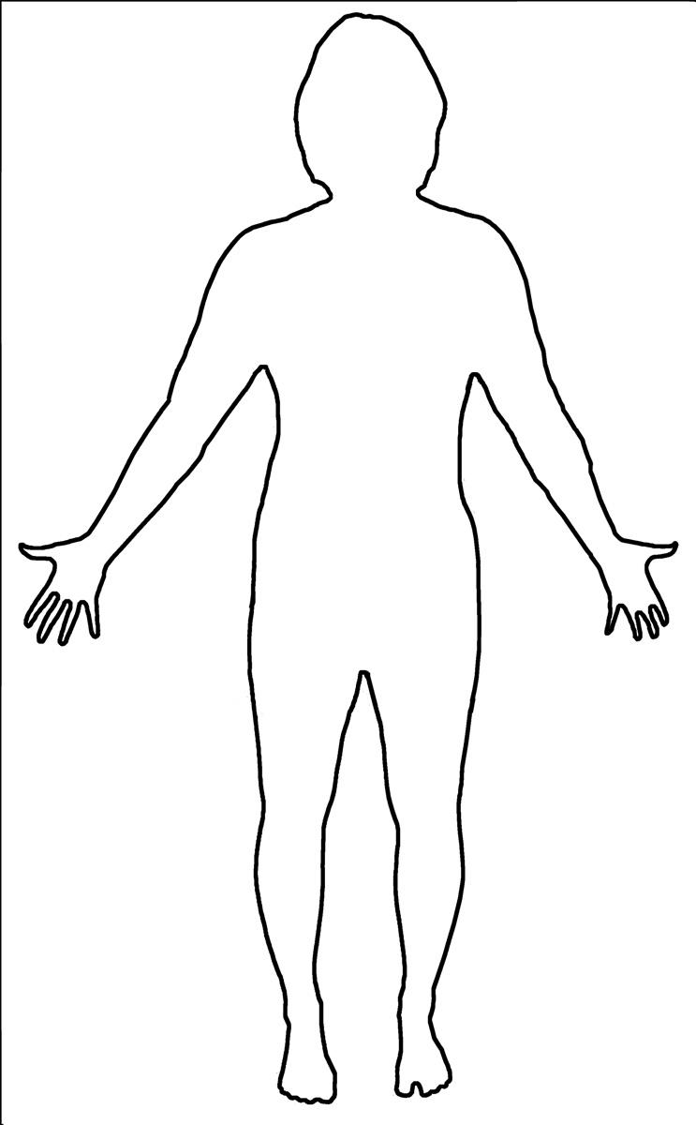
Left Arm/Hand
Carpel Tunnel
”Tennis Elbow”
Numbness in hand
Hand always cold
Other ____________
Left Foot/Ankle
Bunion
Hammertoe
Plantar Facaiitis
Numbness in foot
Foot always cold
Foot pain/injury
Ankle pain/injury
Edema (swelling)
Other _____________

Left Leg/Knee
ACL injury
Cartilage concerns
Knee pain/injury
Leg pain/injury
Edema (swelling)
Knee replacement
Other ______________

Reproductive/Urologic
Menstrual cramps/PMS Yeast/Bladder infections
Infertility/Miscarriage
Urinary incontinence
Erectile dysfunction
Prostate issues
Kidney stones
Other ______________

Right Foot/Ankle
Bunion
Hammertoe
Plantar Facaiitis
Numbness in foot
Foot always cold
Foot pain/injury
Ankle pain/injury
Edema (swelling)
Other _____________

Right Leg/Knee
ACL injury
Cartilage concerns
Knee pain/injury
Leg pain/injury
Edema (swelling)
Knee replacement
Other ______________

Hips/Pelvis
Pelvis pain/injury
Hip pain/injury
Hip replacement
Other _____________
Spine-Lower
Lower back pain/injury
Other _______________
Digestive
Constipation/Diarrhea
Acid Reflux/Heartburn
Diverticulitis
Gallstones
Unexplained weight gain/loss
Other __________________
Organ Function
Diabetes
Kidney disease
Gallstones
Appendicitis
Liver dysfunction
Adrenal dysfunction
Other ______________

Right Arm/Hand
Carpel tunnel
”Tennis Elbow”
Numbness in hand
Hand always cold
Other ____________
Lymphatic
Lymphoma
Lymph node swelling
Breast cancer
Fatigue
Other ___________

Cardiovascular
High blood pressure
High cholesterol
Stroke
Heart disease
Other ___________

Spine-Upper Back
Upper back pain/injury
Other ______________
Right Shoulder
Rotator cuff injury/pain
Shoulder impingement
Shoulder injury/pain
Other ______________
Left Shoulder
Rotator cuff injury/pain
Shoulder impingement
Shoulder injury/pain
Other ______________
Respiratory
Asthma
COPD
Shortness of breath
Lung disease
Other ___________

Neurological/Limbic
Alzheimer’s
Memory loss
Brain fog
Anxiety/Panic Attacks
Depression
Other ____________

Head/neck
TMJ/Teeth grinding
Jaw pain
Headaches
Neck Pain
Hearing/Vision loss
Sinus infections/Allergies
Thyroid dysfunction
Other ______________
Name: ____________________

Please check all conditions you have encountered throughout your lifetime.

